**ASSIGNMENT-27.6:**

Using the given two datasets you need to give a demo on the below joins in hive. Bucket Map join Sort-Merge Bucket join Sort-Merge Bucket Map join Left semi join

Creating two tables:

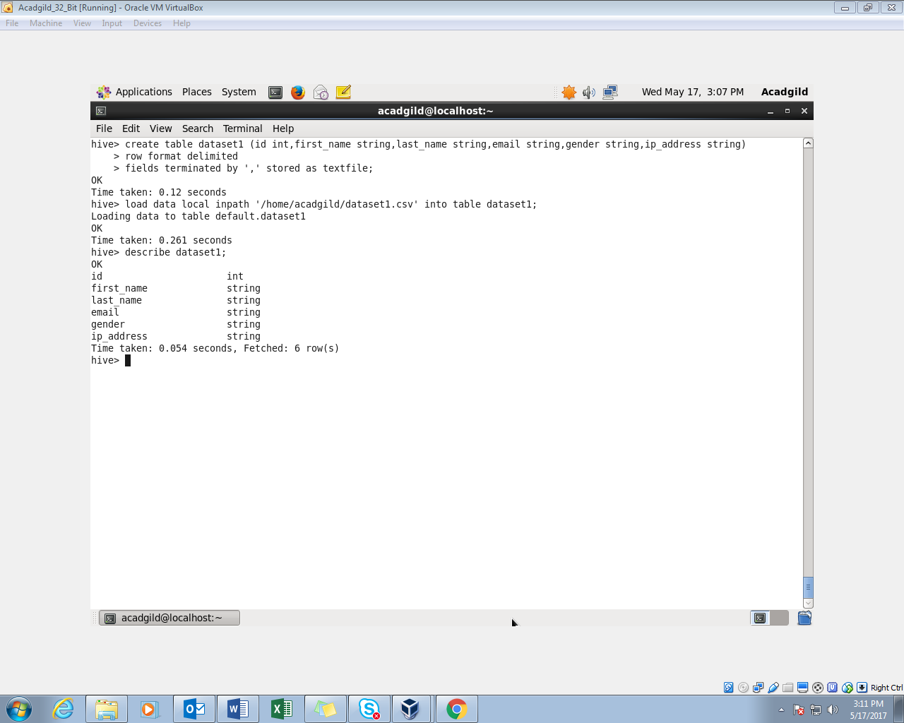

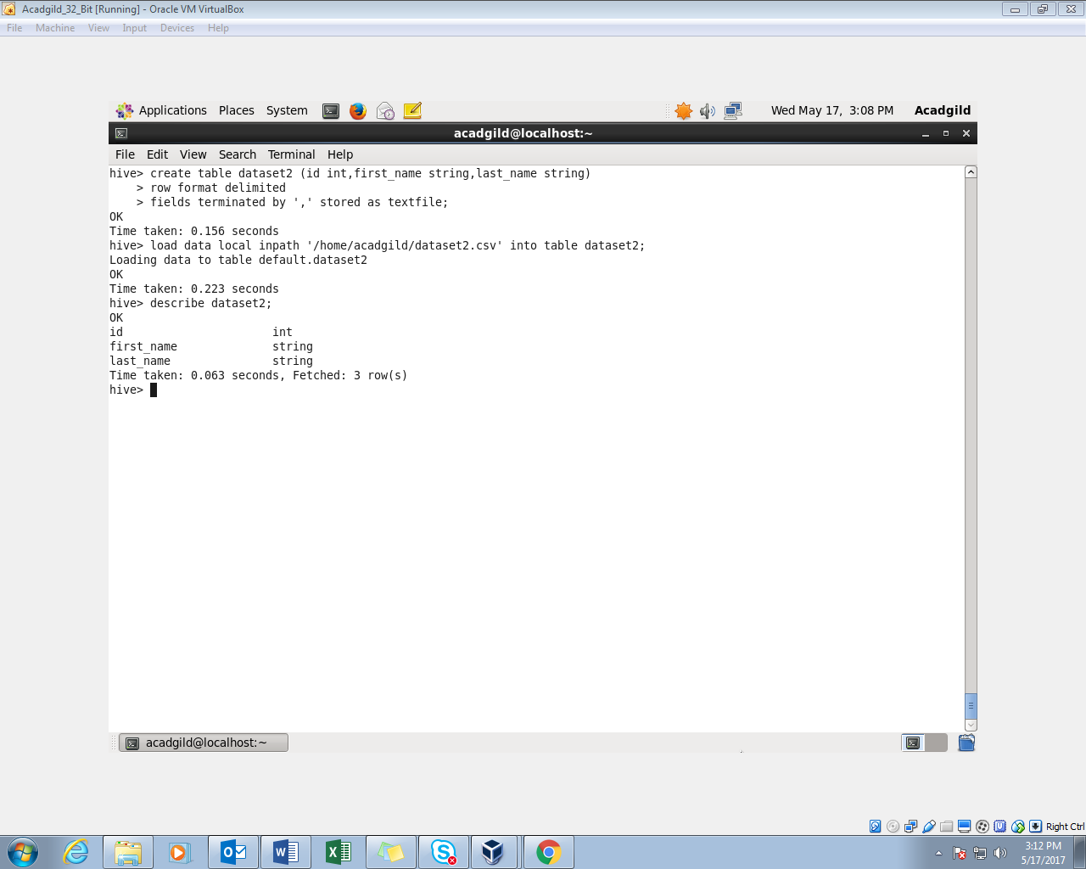

Creating bucket tables: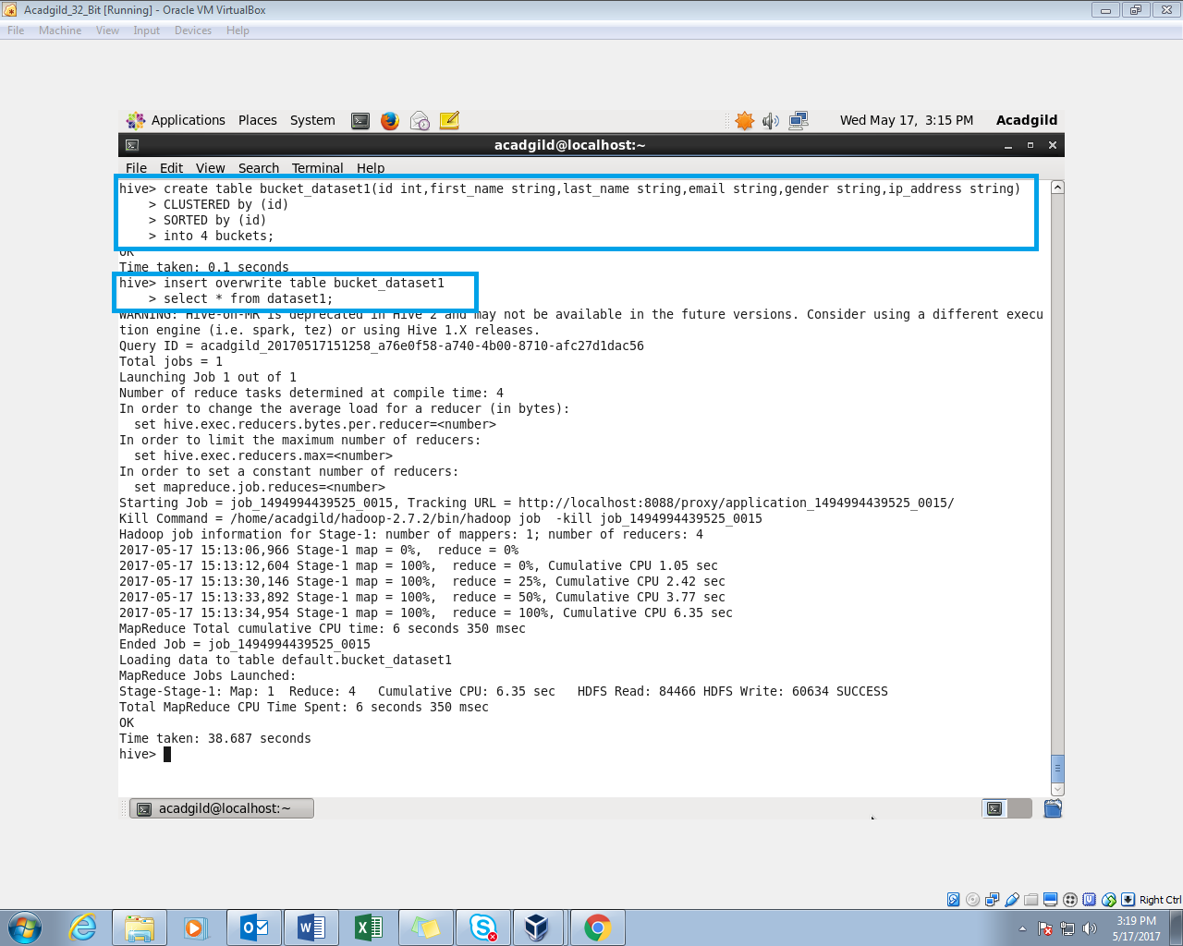 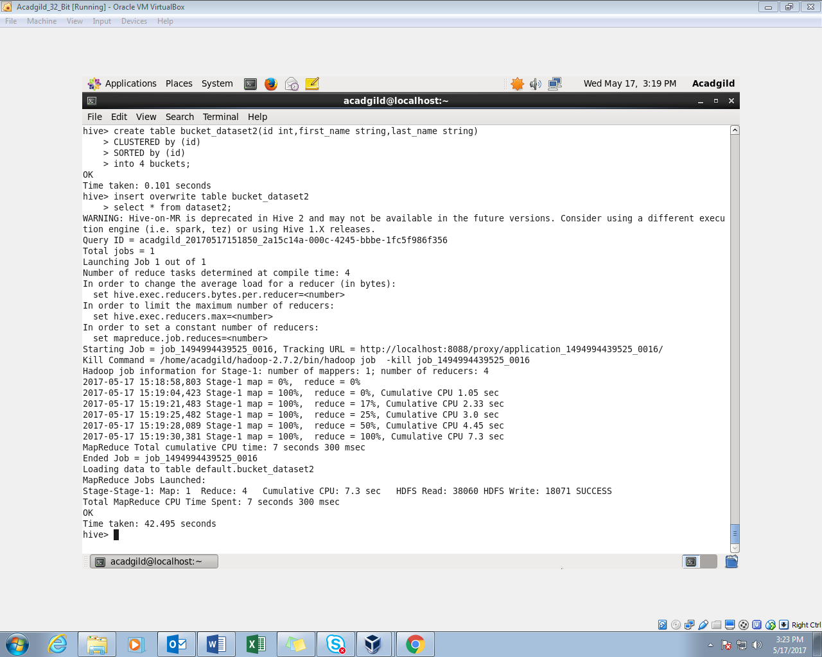

BucketMap Join:

Setting the Bucket Map join to true

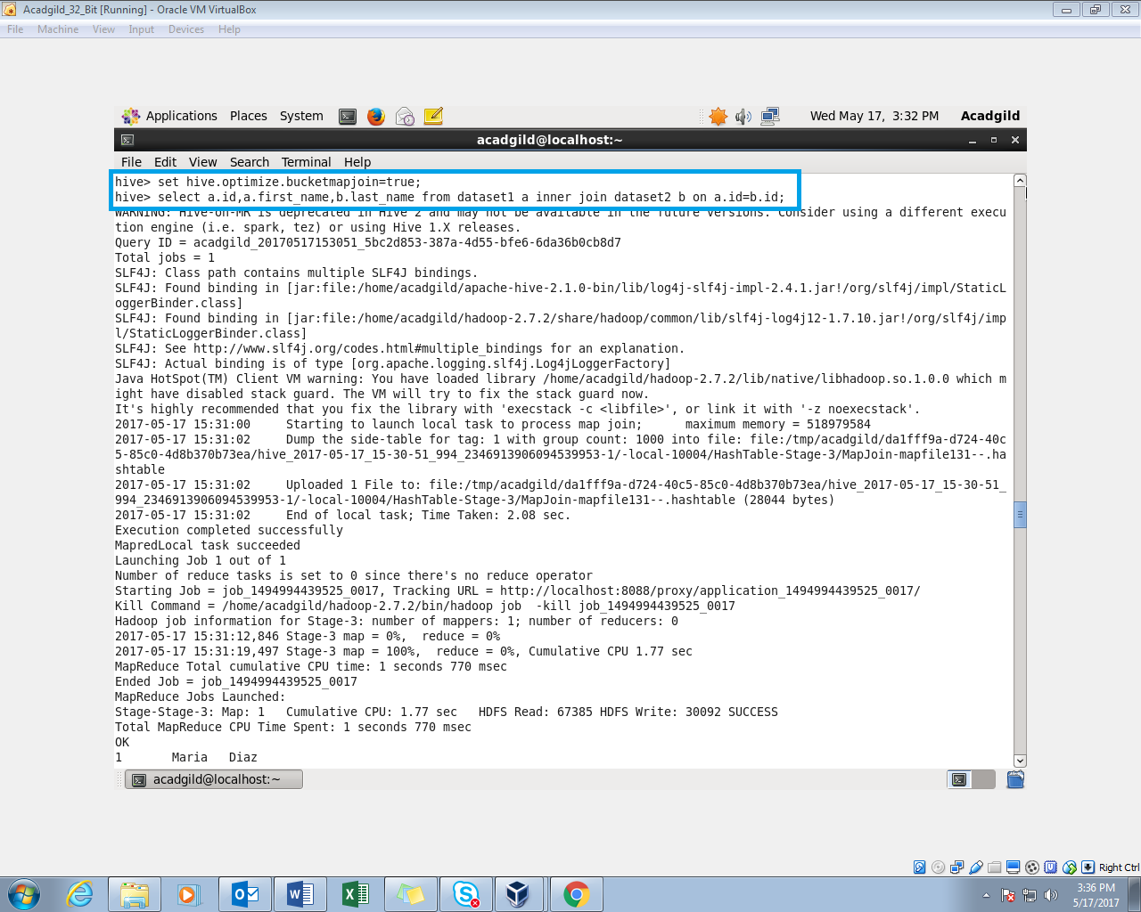

BucketMap Join output: 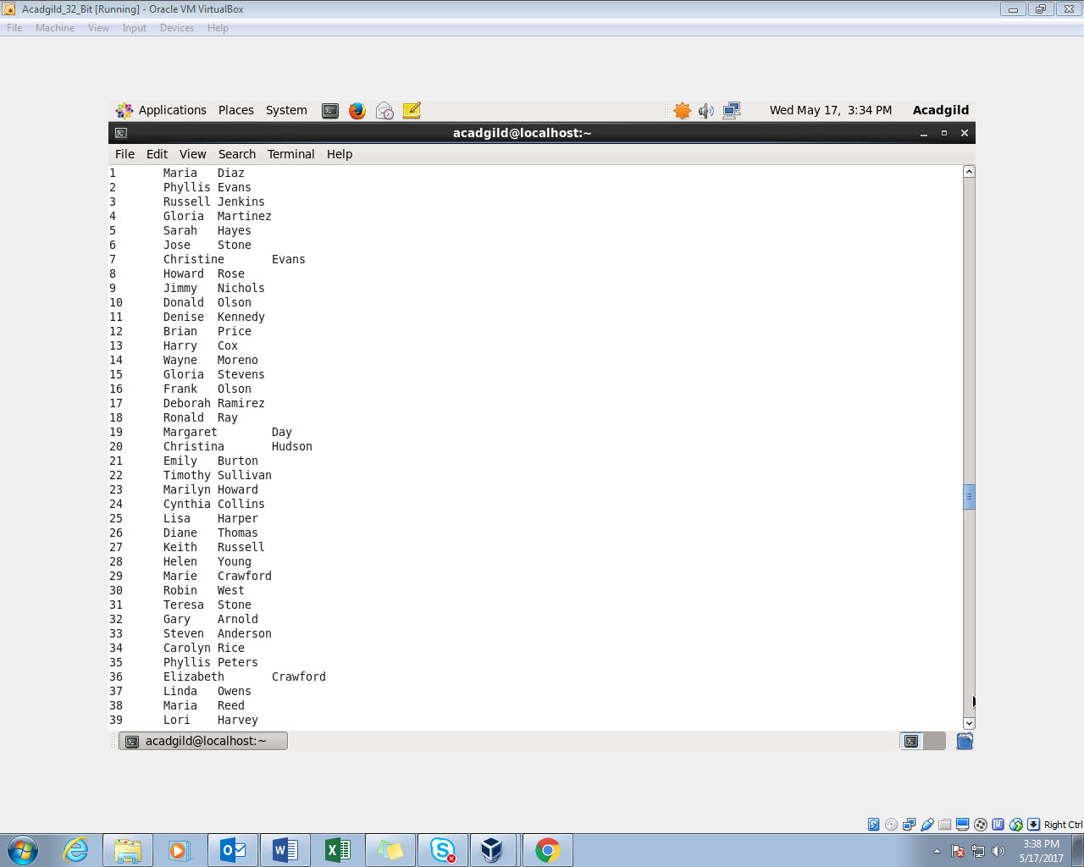

Sort-Merge Bucket join:

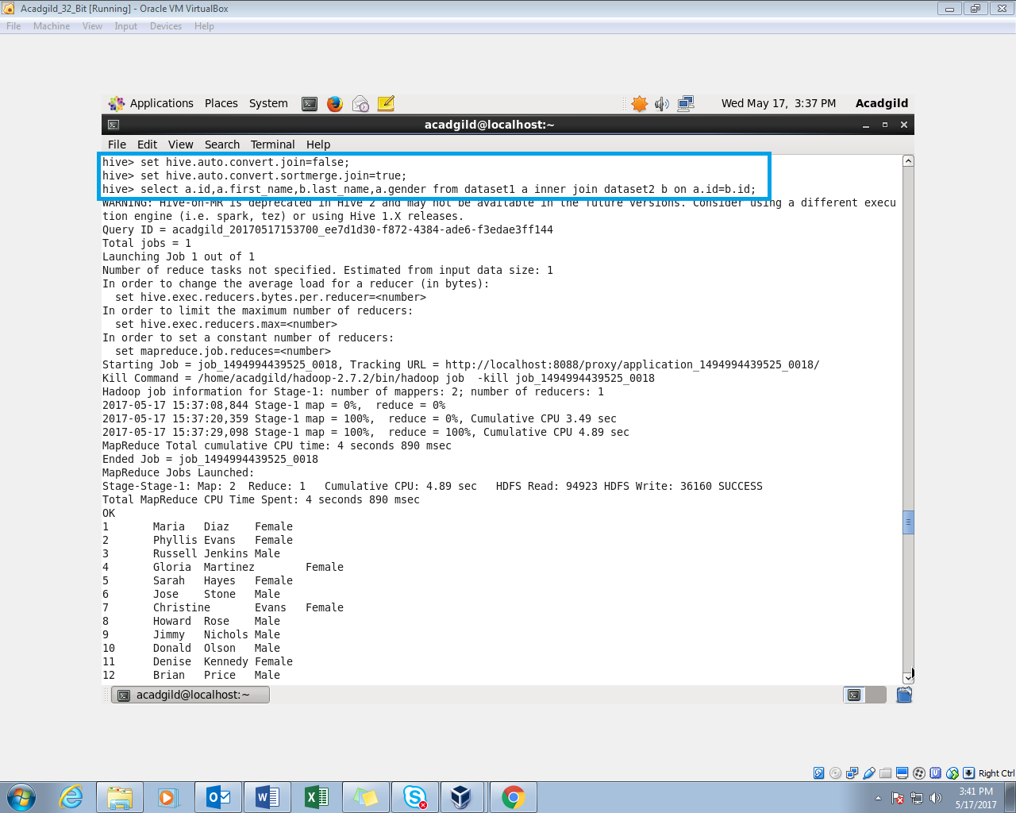

Sort-Merge Bucket join Sample Output:

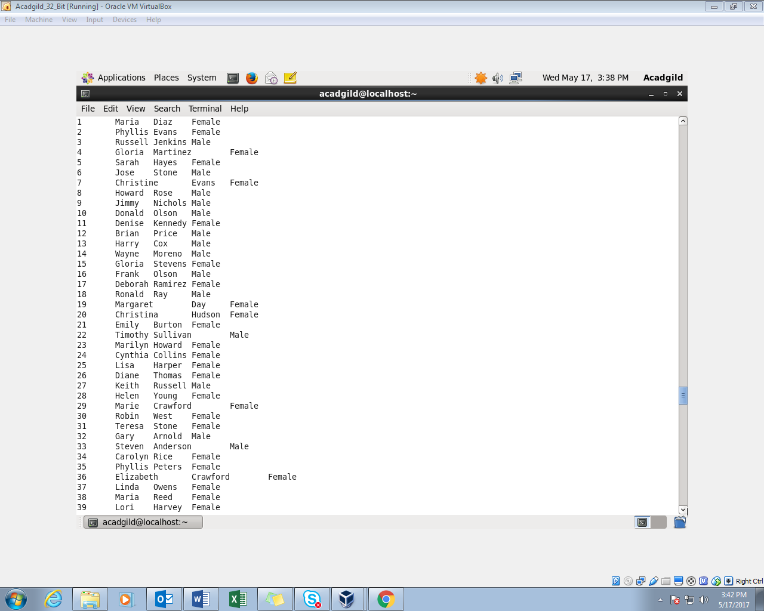

Sort-Merge Bucket Map join:

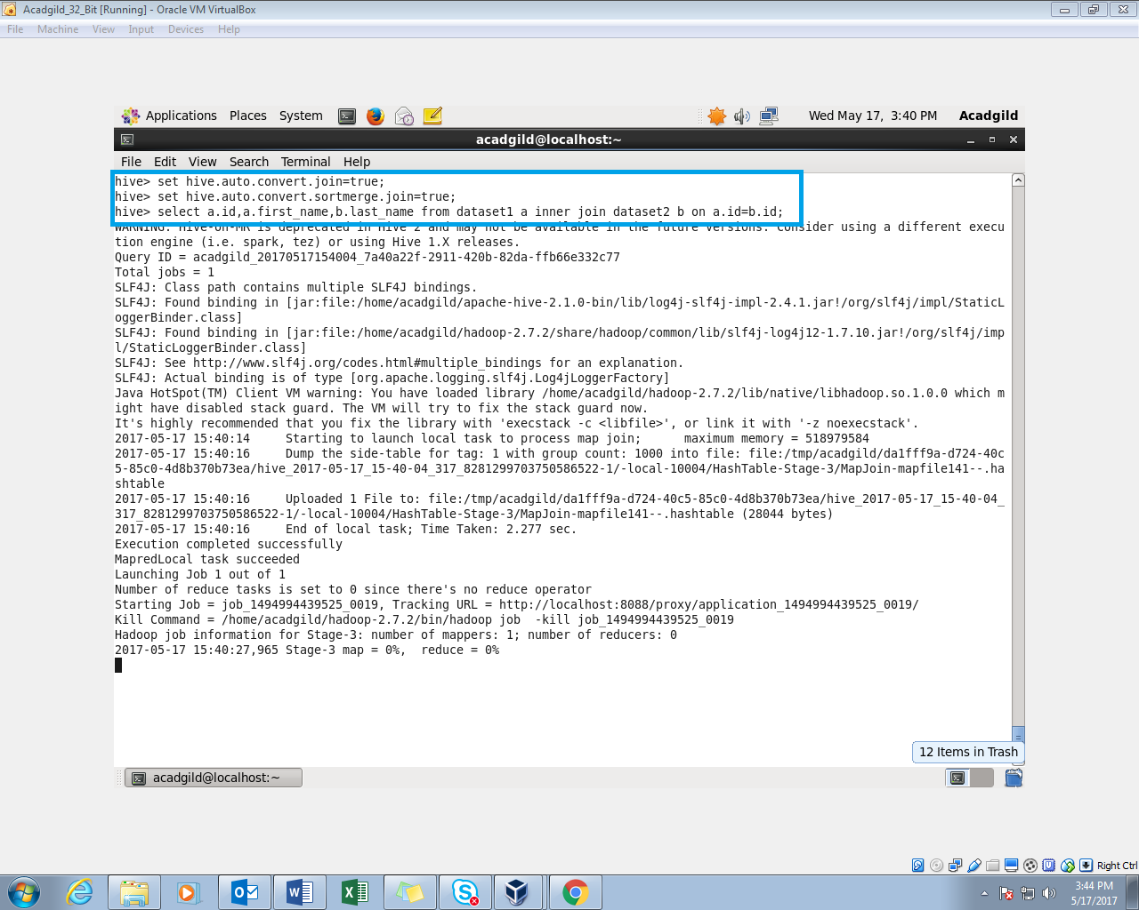

Sort-Merge Bucket Map join Output:

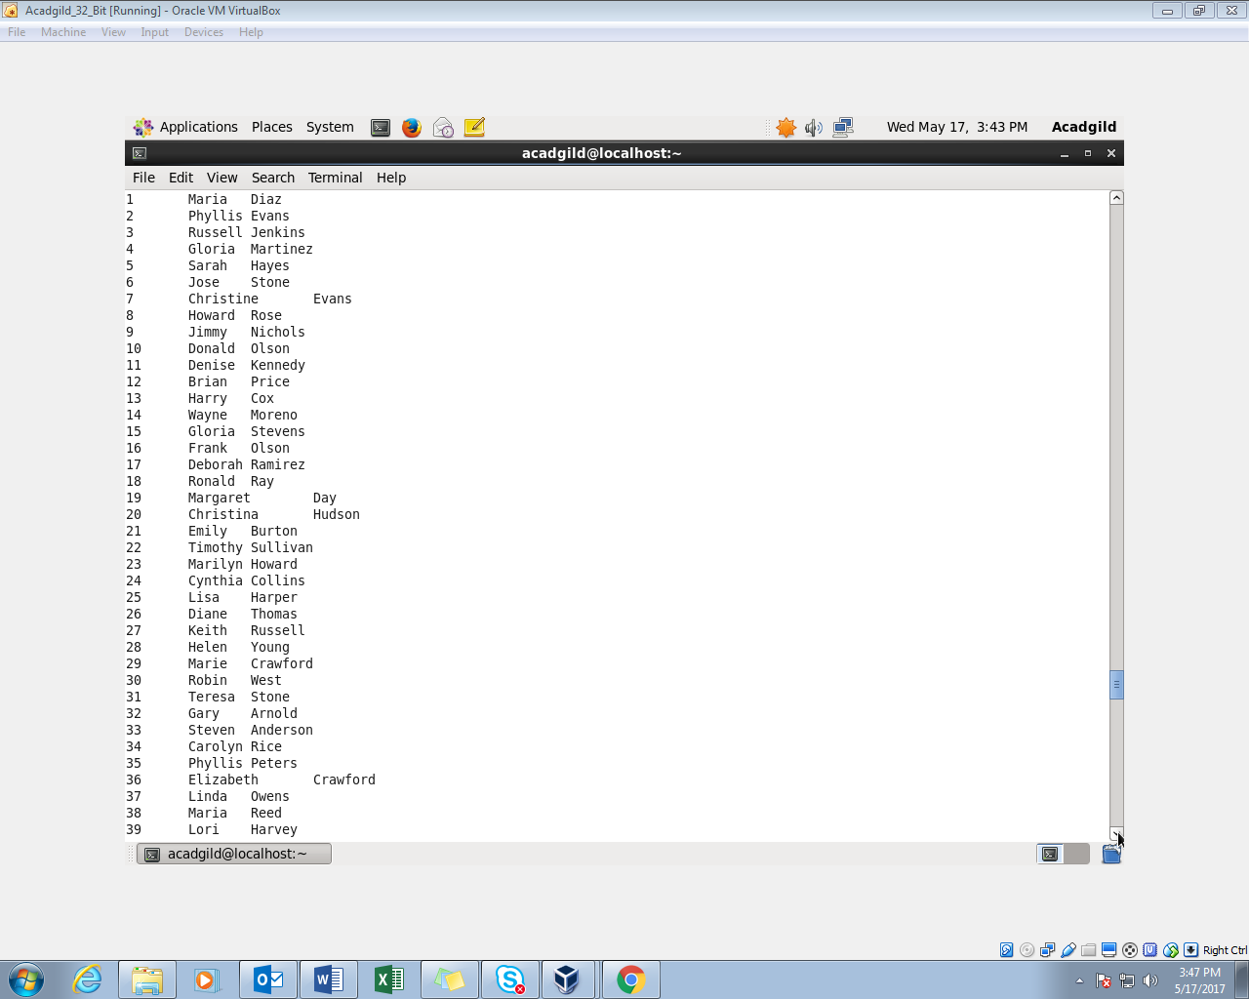

Left semi join:

